Hands-On Data Lab Implementation
Data Analysis Environment Setup and Practical Exercises

Student Name: Sonu Kumar
Internship / Program: Yuva Intern
Date: 14/10/2026

Introduction
This report documents the Hands-On Data Lab task. The goal was to build a working data analysis environment and complete practical exercises in data manipulation, visualization and basic analysis using Python and Jupyter Notebook.
Objectives:
- Set up a data science environment with Python, Jupyter and the required libraries.
- Complete practical exercises in data manipulation, visualization and basic analysis.
Tools used: Python 3, Jupyter Notebook, NumPy, Pandas, Matplotlib, Seaborn and SciPy.

1. Environment Setup
The first step was to prepare the data science environment. I installed Python along with Jupyter Notebook and the libraries needed for analysis: NumPy and Pandas for data handling, Matplotlib and Seaborn for charts, and SciPy for statistical tests. The notebook starts by importing these libraries and printing their versions, which confirms the setup works.
Code
import sys
import numpy as np
import pandas as pd
import matplotlib
import matplotlib.pyplot as plt
import seaborn as sns
from scipy import stats

print("Python :", sys.version.split()[0])
print("NumPy :", np.__version__)
print("Pandas :", pd.__version__)
print("Matplotlib:", matplotlib.__version__)
print("Seaborn:", sns.__version__)

sns.set_theme(style="whitegrid")
Output
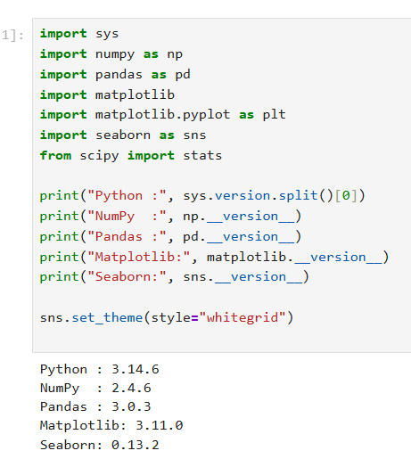

2. Dataset Creation
To keep the lab self-contained, I generated a synthetic retail sales dataset of 500 orders with columns such as order date, region, product category, quantity, unit price, customer age and discount. Missing values and duplicate rows were added on purpose so that real data-cleaning steps could be practised.
Code
rng = np.random.default_rng(42)
n = 500

df = pd.DataFrame({
"order_id": np.arange(1001, 1001 + n),
"order_date": pd.to_datetime("2025-01-01") + pd.to_timedelta(rng.integers(0, 365, n), unit="D"),
"region": rng.choice(["North", "South", "East", "West"], n),
"category": rng.choice(["Electronics", "Clothing", "Grocery", "Furniture"], n, p=[0.25, 0.3, 0.3, 0.15]),
"quantity": rng.integers(1, 10, n),
"unit_price": rng.normal(60, 25, n).round(2).clip(5),
"customer_age": rng.integers(18, 70, n),
})
df["discount"] = rng.choice([0, 0.05, 0.10, 0.20], n, p=[0.5, 0.2, 0.2, 0.1])

# Inject messiness
df.loc[rng.choice(n, 15, replace=False), "customer_age"] = np.nan
df.loc[rng.choice(n, 10, replace=False), "region"] = None
df = pd.concat([df, df.sample(5, random_state=1)], ignore_index=True) # duplicates

df.head()
Output
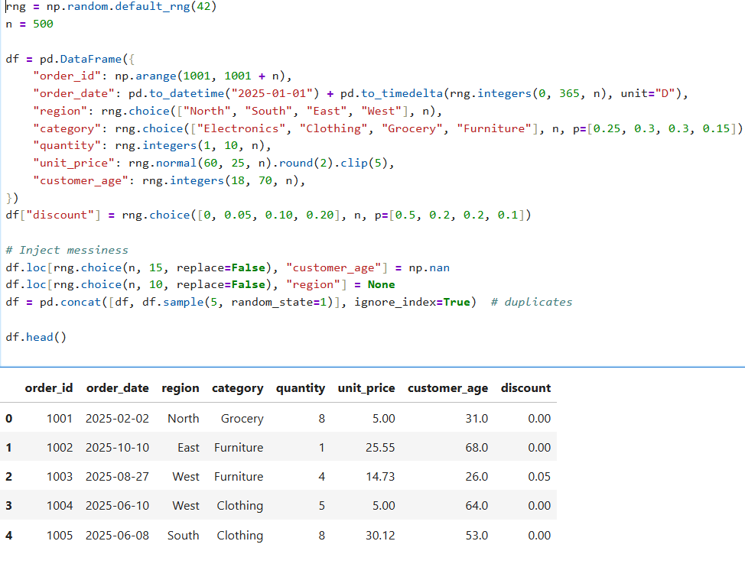

3. Data Manipulation
3.1 Exploring the data. I checked the shape, column types, summary statistics, missing values and duplicates. The data had 505 rows, 10 missing regions, 15 missing customer ages and 5 duplicate rows.
Code
print("Shape:", df.shape)
df.info()
Output
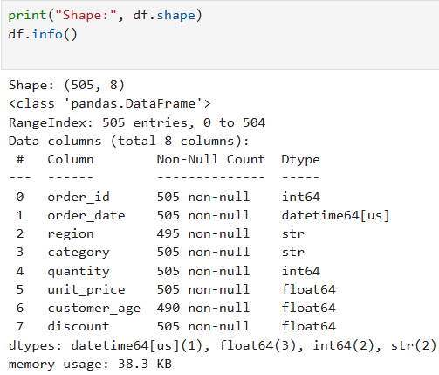

Code
print(df.isna().sum())
print('Duplicate rows:', df.duplicated().sum())
Output
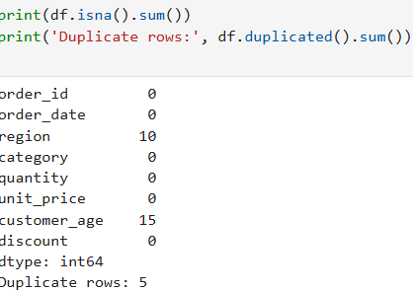

3.2 Cleaning the data. Duplicate rows were removed, missing ages were filled with the median age, and missing regions were labelled 'Unknown'. After cleaning, the dataset has 500 rows and no missing values.
Code
df = df.drop_duplicates().copy()
df["customer_age"] = df["customer_age"].fillna(df["customer_age"].median())
df["region"] = df["region"].fillna("Unknown")

print("Missing values left:", df.isna().sum().sum())
print("Shape after cleaning:", df.shape)
Output
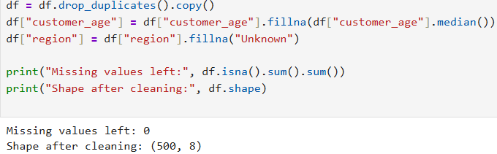
3.3 Feature engineering. I created a revenue column (quantity x price after discount), a month column from the order date, and age groups using binning.
Code
df["revenue"] = df["quantity"] * df["unit_price"] * (1 - df["discount"])
df["month"] = df["order_date"].dt.to_period("M").astype(str)
df["age_group"] = pd.cut(df["customer_age"], bins=[17, 30, 45, 60, 100],
labels=["18-30", "31-45", "46-60", "60+"])
df[["order_id", "quantity", "unit_price", "discount", "revenue", "month", "age_group"]].head()
Output
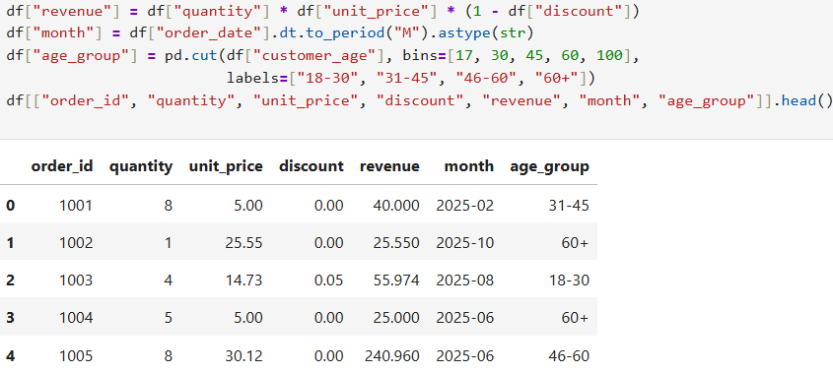

3.4 Filtering, grouping and pivoting. I filtered high-value orders (revenue above 400), summarised sales by category with groupby, and built a pivot table of revenue by region and category.
Code
# Filter: high-value orders
high_value = df[df["revenue"] > 400]
print("High-value orders:", len(high_value))

# Group: revenue by category
cat_summary = (df.groupby("category")
.agg(orders=("order_id", "count"),
total_revenue=("revenue", "sum"),
avg_revenue=("revenue", "mean"))
.sort_values("total_revenue", ascending=False)
.round(2))
cat_summary
Output
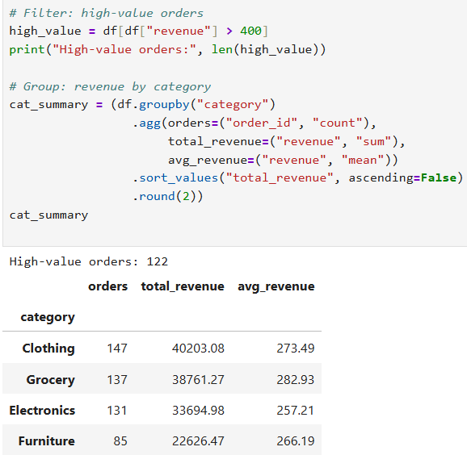

Code
# Pivot table: revenue by region and category
pivot = df.pivot_table(values="revenue", index="region", columns="category",
aggfunc="sum", margins=True).round(0)
pivot
Output
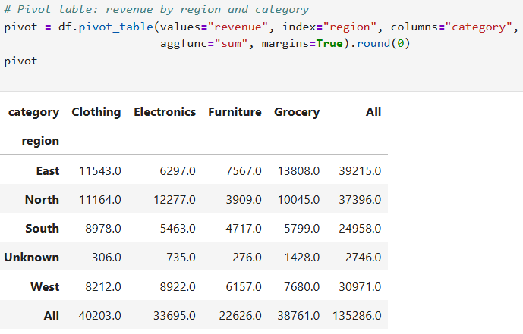

4. Data Visualization
4.1 Revenue by category. Clothing earns the highest total revenue, followed by Grocery, Electronics and Furniture.
Code
plt.figure(figsize=(8, 5))
sns.barplot(data=cat_summary.reset_index(), x="category", y="total_revenue", palette="viridis")
plt.title("Total Revenue by Category")
plt.xlabel("Category"); plt.ylabel("Revenue")
plt.tight_layout(); plt.show()
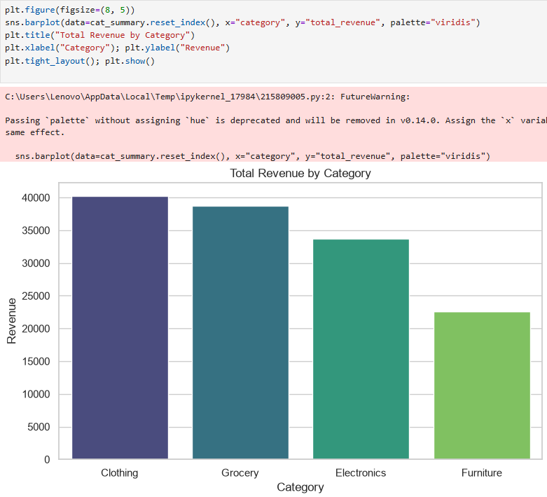

4.2 Monthly revenue trend. The line chart shows how revenue changes across the months of the year.
Code
monthly = df.groupby("month")["revenue"].sum()
plt.figure(figsize=(10, 5))
plt.plot(monthly.index, monthly.values, marker="o", color="tab:blue")
plt.xticks(rotation=45)
plt.title("Monthly Revenue Trend")
plt.xlabel("Month"); plt.ylabel("Revenue")
plt.tight_layout(); plt.show()
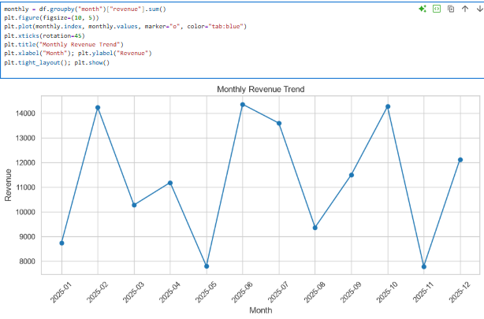

4.3 Revenue distribution. The histogram shows that most orders have low to medium revenue, with a long tail of a few high-value orders (right-skewed).
Code
plt.figure(figsize=(8, 5))
sns.histplot(df["revenue"], bins=30, kde=True, color="teal")
plt.title("Distribution of Order Revenue")
plt.xlabel("Revenue")
plt.tight_layout(); plt.show()

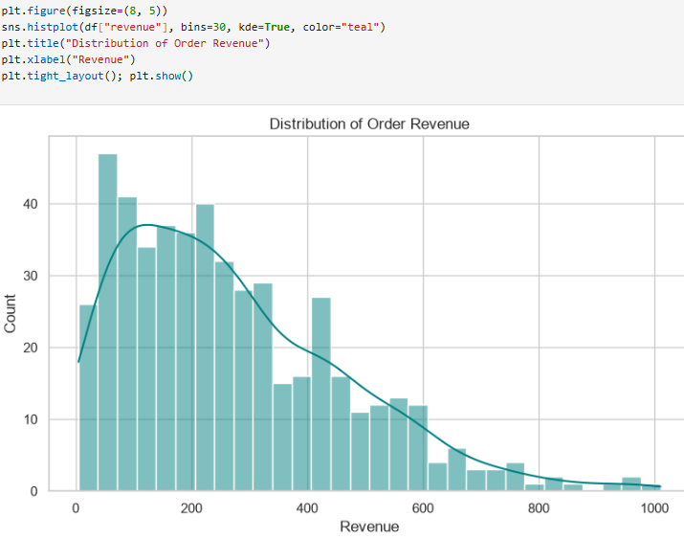

4.4 Revenue by region. The box plot compares the spread of order revenue across the four regions and shows a few high outliers.
Code
plt.figure(figsize=(8, 5))
sns.boxplot(data=df, x="region", y="revenue", palette="Set2")
plt.title("Revenue Spread by Region")
plt.tight_layout(); plt.show()
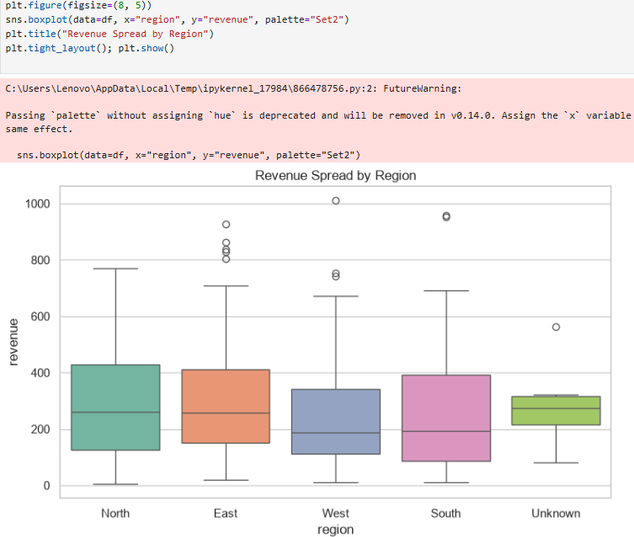

4.5 Correlation heatmap. Revenue is strongly related to quantity and unit price, while customer age and discount show almost no relationship with it.
Code
corr = df[["quantity", "unit_price", "discount", "customer_age", "revenue"]].corr()
plt.figure(figsize=(7, 5))
sns.heatmap(corr, annot=True, cmap="coolwarm", fmt=".2f", vmin=-1, vmax=1)
plt.title("Correlation Matrix")
plt.tight_layout(); plt.show()

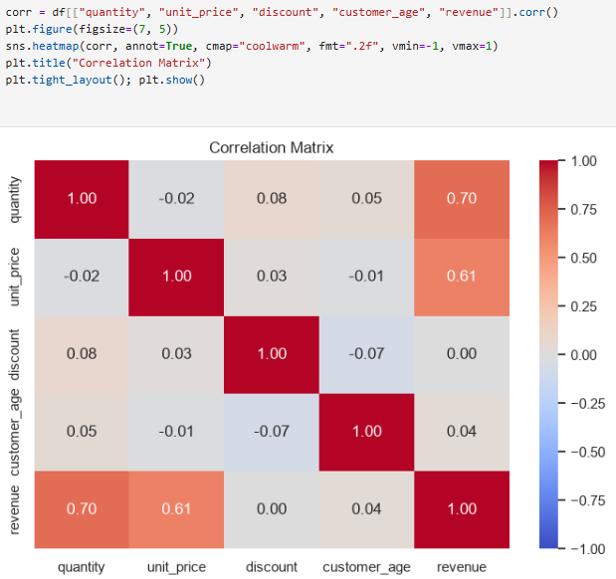

5. Basic Analysis
5.1 Descriptive statistics. The mean revenue (about 270) is higher than the median (about 229), and the skewness is positive, confirming a right-skewed distribution.
Code
rev = df["revenue"]
print(f"Mean : {rev.mean():.2f}")
print(f"Median : {rev.median():.2f}")
print(f"Std Dev: {rev.std():.2f}")
print(f"Min/Max: {rev.min():.2f} / {rev.max():.2f}")
print(f"Skew : {rev.skew():.2f}")
Output
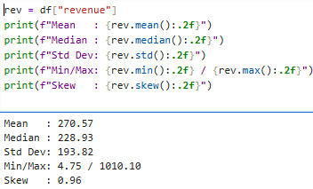

5.2 Outlier detection. Using the IQR method, 7 orders were flagged as unusually high-value outliers.
Code
q1, q3 = rev.quantile([0.25, 0.75])
iqr = q3 - q1
lower, upper = q1 - 1.5 * iqr, q3 + 1.5 * iqr
outliers = df[(rev < lower) | (rev > upper)]
print(f"Bounds: {lower:.2f} to {upper:.2f}")
print(f"Outliers found: {len(outliers)}")
Output
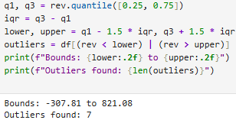
5.3 Hypothesis test. A one-way ANOVA tested whether average revenue differs by region. With p = 0.2052 (above 0.05), there is no statistically significant difference between regions.
Code
groups = [g["revenue"].values for _, g in df.groupby("region")]
f_stat, p_val = stats.f_oneway(*groups)
print(f"F-statistic = {f_stat:.3f}, p-value = {p_val:.4f}")
print("Significant difference between regions" if p_val < 0.05
else "No significant difference between regions (p >= 0.05)")
Output
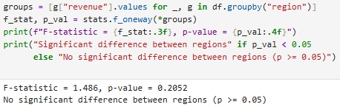
5.4 Linear regression. Quantity explains about 49% of the variation in revenue (R-squared = 0.488), and the relationship is highly significant.
Code
res = stats.linregress(df["quantity"], df["revenue"])
print(f"Slope = {res.slope:.2f}, Intercept = {res.intercept:.2f}")
print(f"R-squared = {res.rvalue**2:.3f}, p-value = {res.pvalue:.4g}")

plt.figure(figsize=(8, 5))
sns.regplot(data=df, x="quantity", y="revenue", scatter_kws={"alpha": 0.4})
plt.title("Quantity vs Revenue")
plt.tight_layout(); plt.show()
Output
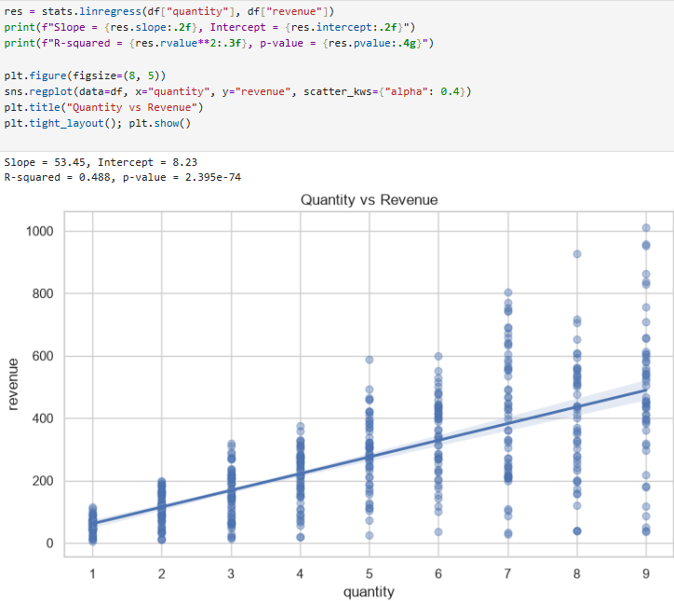

6. Key Findings
The notebook ends with a summary of the main results.
Code
top_cat = cat_summary.index[0]
top_region = df.groupby("region")["revenue"].sum().idxmax()
best_month = monthly.idxmax()

print("KEY FINDINGS")
print("-" * 40)
print(f"1. Top category by revenue : {top_cat}")
print(f"2. Top region by revenue : {top_region}")
print(f"3. Best month : {best_month}")
print(f"4. Average order revenue : {rev.mean():.2f}")
print(f"5. Quantity explains {res.rvalue**2:.0%} of revenue variation")
Output
